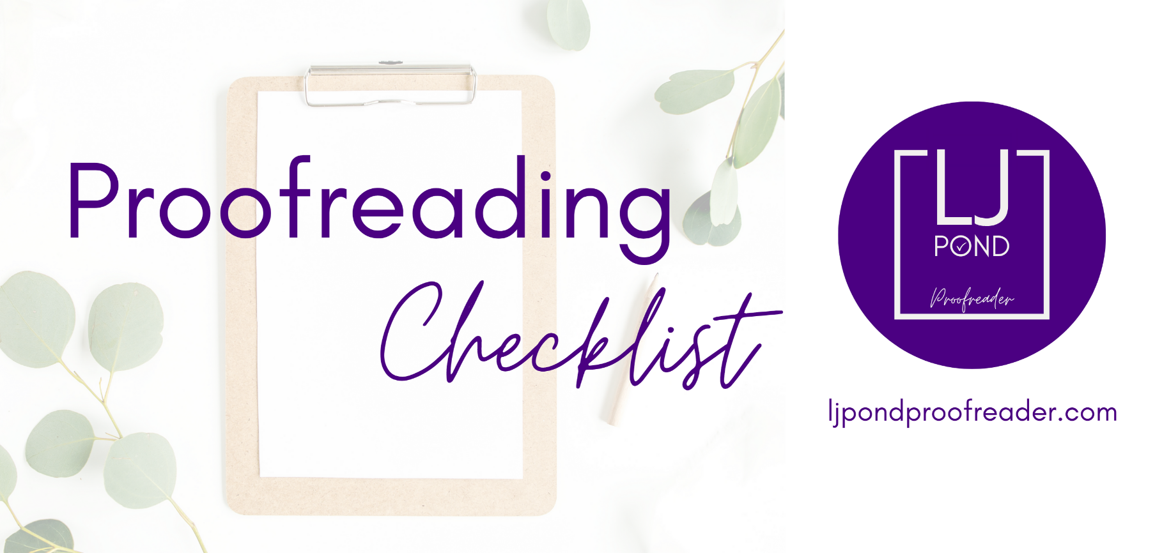
This is a generic checklist designed to help you proofread your own writing. Some of the elements included may not apply to your project, and there may be other elements in your project that are not listed here. For a customised checklist, please get in touch via my website.

How to use this checklist
- Prepare to proofread by reading through the checklist and adding details of your own style, e.g. the size of font you want to use for your headings.

- Use the items in the checklist to guide you through your text. Deal with one item at a time, e.g. look at all of your level 1 headings together. Check that each item is used accurately and that all of the examples are consistent with each other. When you’ve checked all of the examples, move to the next item on the list.

- Add any additional items that need to be checked in the ‘Other’ section on page 6. Work through these in the same way.

- For additional support with proofreading, reach out to me via my website: ljpondproofreader.com.
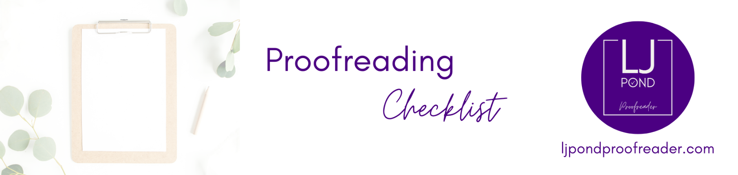
Overview
(Add general details of your project here.)
Title of project
Author
Variety of English (e.g. UK, USA)

Headings
Level 1 headings
☐ consistent font | ☐ consistent size and colour
☐ bold or italic, if needed | ☐ use of capital letters, if needed
☐ accurate spelling | ☐ accurate use of punctuation
☐ alignment (left/right/centred/justified)
Level 2 headings
☐ consistent font | ☐ consistent size and colour
☐ bold or italic, if needed | ☐ use of capital letters, if needed
☐ accurate spelling | ☐ accurate use of punctuation
☐ alignment (left/right/centred/justified)

Non-textual elements
(Images, tables, diagrams, buttons, etc.)
☐ consistent font | ☐ consistent size and colour of font
☐ bold or italic, if needed | ☐ correct alignment
☐ consistent use of spacing | ☐ accurate position
Images and diagrams
☐ accurate captions and labels, if any
☐ clear, good quality
☐ alt text, if needed
Tables
☐ accurate and consistent alignment within the table

Text: format
Font name:
Font size and colour:
☐ consistent font | ☐ consistent size and colour of font
☐ bold or italic, if needed | ☐ consistent alignment
☐ consistent use of spacing

Text: language use
Names: accurate spelling and use of capital letters
(List all of the names that appear in your text to help you check, e.g. names of people/products)

☐  ☐  ☐ | ☐  ☐  ☐
Spelling
(Some commonly misspelled words and typos to check for are: there/their/they’re; it’s/its; your/you’re; definitely; separate; then/than; were/we’re/where; lose/loose; and/an)

☐ accurate and consistent
☐ accurate spelling of plural forms, e.g. ‘men’ NOT ‘man’s’

Numbers
(Will you write out any numbers in words, e.g. ‘one’ vs. ‘1’?)

☐ consistent use
☐ accurate spelling and use of hyphens in numbers that are written out
Words with hyphens
(List any words that you hyphenate, e.g. ‘self-care’ vs. ‘self care’ to help you check.)

☐  ☐ | ☐  ☐
Text: language use (continued)
Grammar
(This is a very short list of areas of grammar to pay attention to. Add anything else that you know you tend to make mistakes with to help you catch any errors.)

☐ complete sentences
☐ subject–verb agreement, e.g. ‘he is’ vs. ‘they are’
☐ accurate use of verb tenses, ‘I have done it’ vs. ‘I done it’
☐
☐

Punctuation

☐ full stops (or an alternative, if needed) at the end of each sentence
☐ accurate use of apostrophes
(An apostrophe is used to show possession, NOT to make a plural form, e.g. the dog’s breakfast)
☐ accurate use of commas
(A common error writers make with commas is using them to connect independent ideas together, e.g. ‘I like chocolate, my sister likes strawberry.’ Possible corrections: ‘I like chocolate, but my sister likes strawberry’; ‘I like chocolate. My sister likes strawberry.’)
Abbreviations

☐ accurate spelling and punctuation
☐ consistent use

Other
(Add any other items that you need to check in this space.)
Item:

☐
☐
☐
☐

Item:

☐
☐
☐
☐

Item:

☐
☐
☐
☐

